How to Download and Run the ENG 3001 Sentence Exercises App
Prof. Gerard Dalgish, Emeritus, Baruch College

1. Download and Unzip the “Zip” Compressed File to Your Windows Computer
The App comes with a few extra pieces, so I have created a “.Zip” -type file which compresses the app and its accompanying files in a single, smaller file. Baruch BCTC will not allow your professor or me to send you a .zip file as an attachment to email. Instead, we can send you a link to DropBox where you can download the .zip file. You might already know how to do this.
Typically when you download a file, it goes to your “Download” folder on your computer. Using File Explorer, you would navigate to the Downloads folder, where you might see a screen that looks like this:
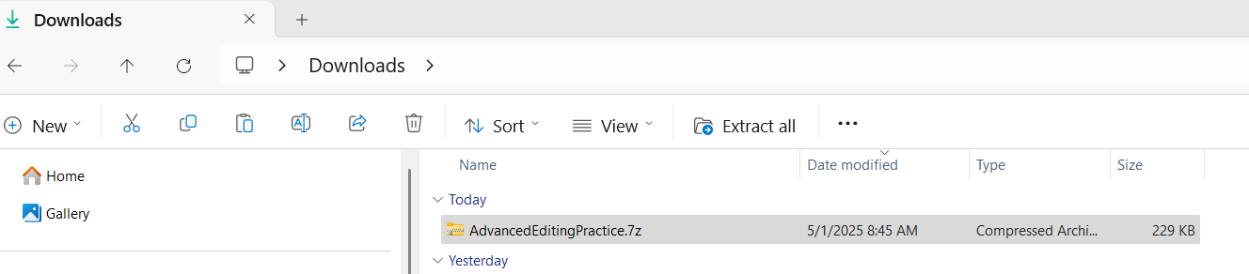
(Your computer might be able to unzip this file without your needing to obtain the “7z” app itself.)
You need to right-click on the “AdvancedEditingPractice.7z” file (do not simply click or double-click, please).
One of your options then should be “Extract All.” Select this Option. Your screen will then look like this:
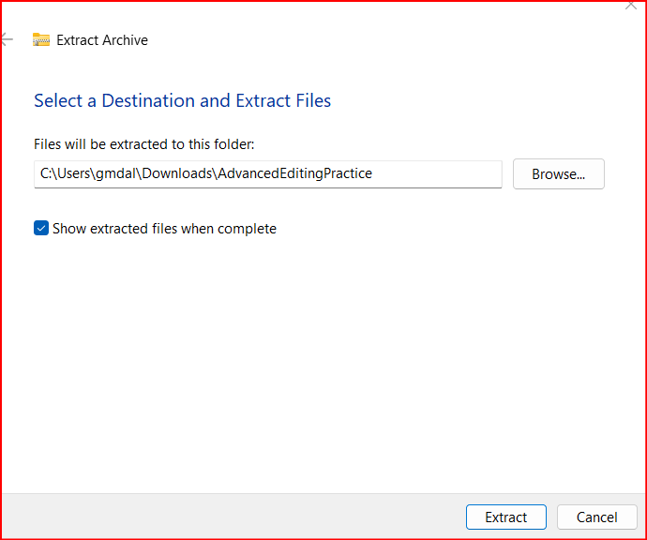
Click on the Extract button and a folder will be created with the name “AdvancedEnglishEditingPractice.” In that folder is the file you’ll use to start the app.
Note: Possibility 1: You might need to use File Explorer to open the folder called “AdvancedEditingPractice” and click on it to navigate down into it:
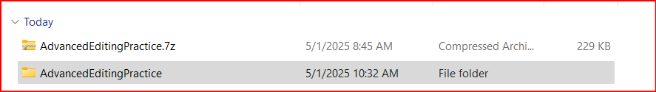
Note: Possibility 2: Sometimes Windows opens that newly created folder automatically, so you might see a screen like this one below (having skipped the step above):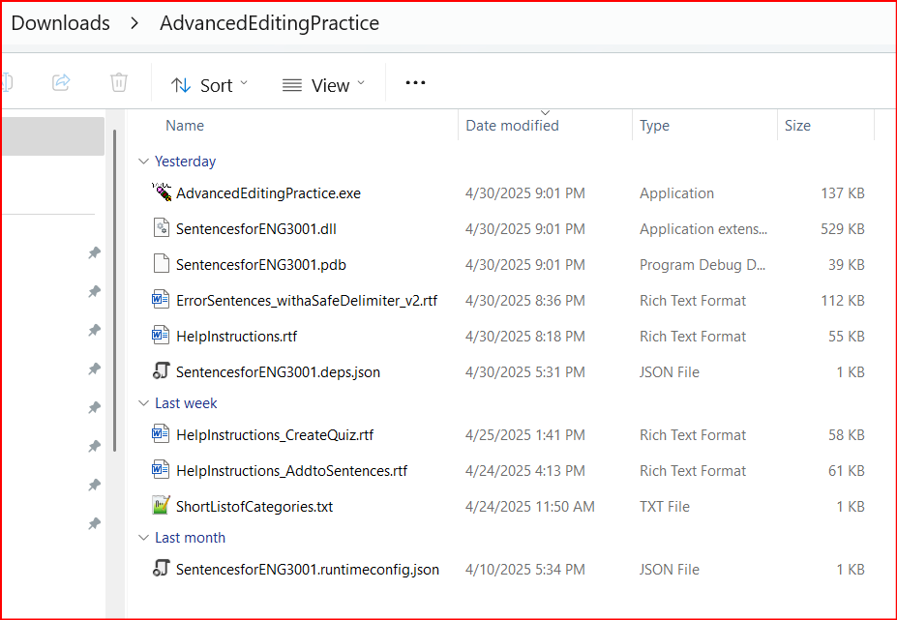
The file that is circled above is called AdvancedEditingPractice.exe. You can double-click on it and the file App should start.
NOTE: You might be presented with a message that suggests that you should NOT open or run the app. You can rest assured my file has nothing of danger to your computer. The message usually has a “More Info” link or button; please click that. You should then see a button or box that says “Run Anyway.” You can safely click that.

2. Running the App.
When you double-click the AdvancedEditingPractice.exe file, it should start automatically. You should see a “splash screen” that lasts no more than 10 seconds:
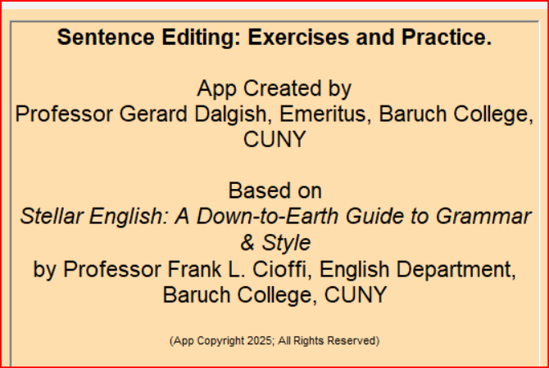
The “Splash Screen” should disappear after 10 seconds (I hope you can read quickly!), and the App starts with a Help screen in the middle:
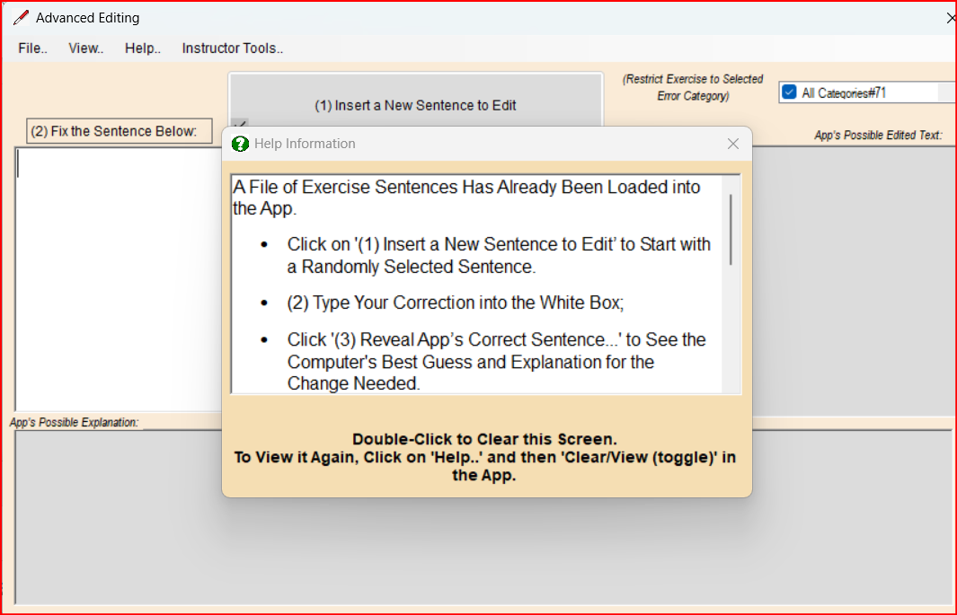
You can read the instructions and scroll down to see the remaining information. To clear the Help Screen you will need to double-click on the help screen (where it says “Double-Click to Clear this Screen”) to continue to the exercise portion. Note: (on the upper left of the app you will see a set of menu choices. Click on “Help..” and then on “Clear/View Help Screen (toggle)” and the Help screen should vanish. If you click that menu item again, the Help Screen will re-appear if you need to read the instructions again).
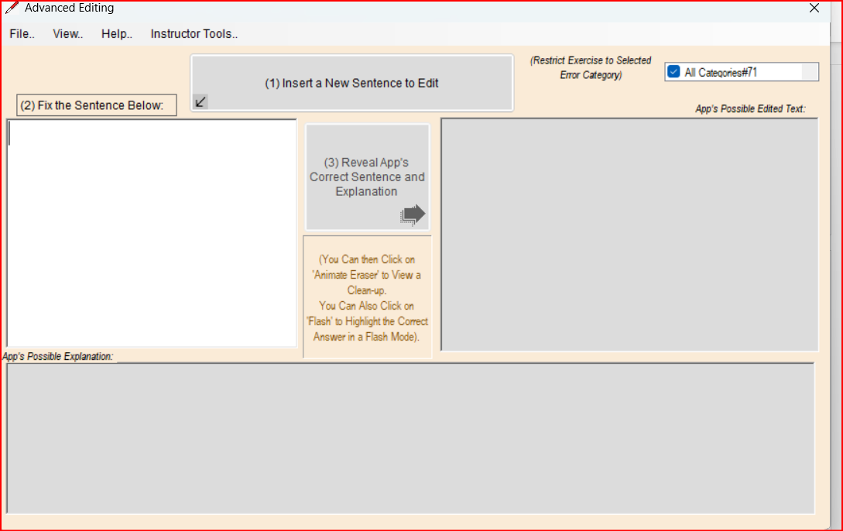
The instructions in the Help screen told you that the App has already loaded sentences for you to work on. The sequence of steps corresponds to the numbers on the buttons:
Step (1): Click the button that says “(1) Insert a New Sentence to Edit”. The App will randomly select a sentence from the prepared list and present it in the white box:
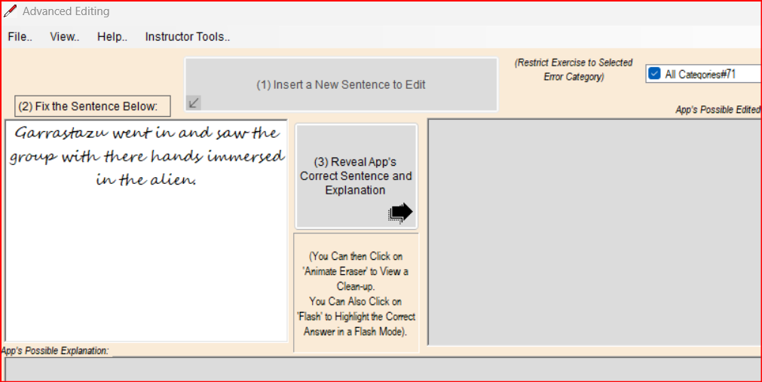
Step (2): “Fix the Sentence Below.” Your cursor should be in the white box. Read the sentence and try to find the likely error that needs to be edited. In this case sentence, it’s the word there that is incorrect. You need to change there to their; that’s the expected correction here (no need to change anything else in the sentence. Simply delete there and type their instead.
Step (3): “Reveal App’s Correct Sentence and Explanation.” Click the button that says “Reveal App’s Correct Sentence and Explanation.” If your edit is correct, the app places a “thumbs up” sign at the end of that editing box. To the right, in the gray box under the caption “App’s Possible Edited Text,” you’ll see the expected right answer, and below that, the explanation:
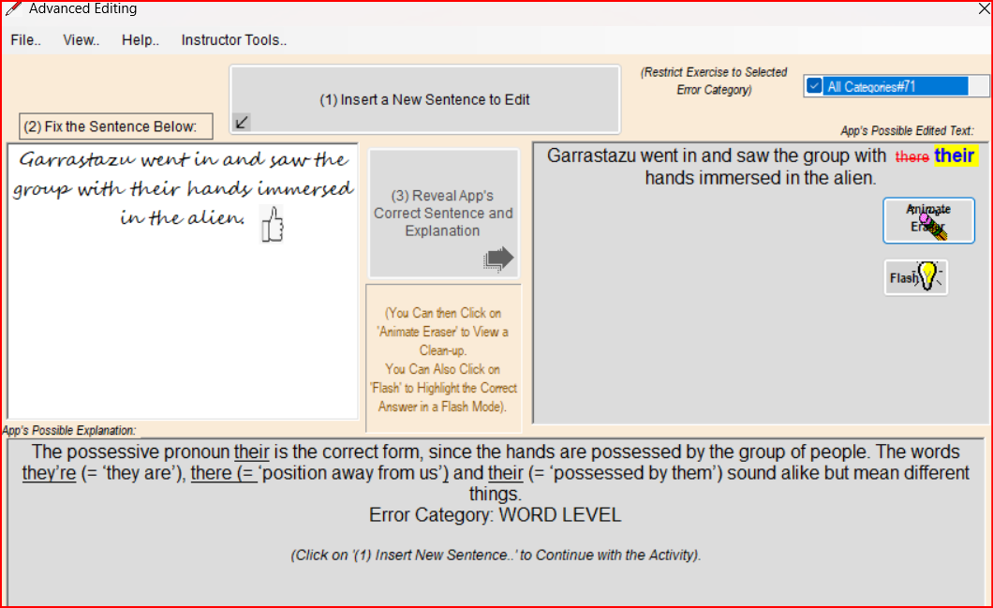
You can click on the “Animate Eraser” button on the right and a flying pencil will “erase” the wrong answer. The expected right answer will be highlighted in yellow, and if you click the “flash” button, you can watch the highlighting blink on and off on the expected answer.
When you have had enough of this sentence, you can click on “(1) Insert a New Sentence to Edit” and then repeat the Steps (2) – (3).
Additional Options:
Keeping the Sentences from the Session. The App will remember the sentences it presented to you, record your edits, and remember the expected answers and explanations. When you have completed as many sentences as you like, you can click on the menu item (at the top of the App) “View..” and then on “View Sentences from the Current Session (toggle).” Your screen might look like this:
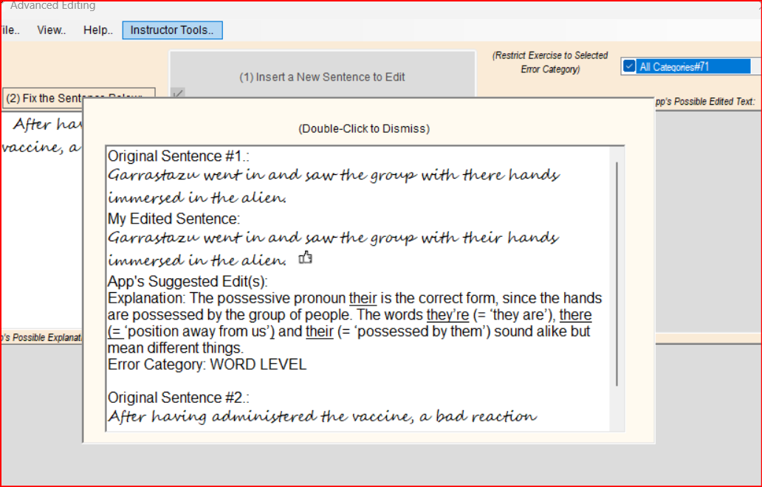
This could be useful for you to read through. You might find that you disagree with the App’s answer, or you might wonder if another answer is possible. AI can’t answer those questions for you, but your professor can. You can save this file as a Word file and print it out, or send it to your professor for discussion purposes. At any rate, you can double-click on the panel to dismiss the view (or click on the menu item “View” and then “View Sentences..toggle” and it should clear from view).
To save a file of your current session (as seen above), click on the menu item “File” and then on “Save File of Sentences from Current Session..”:
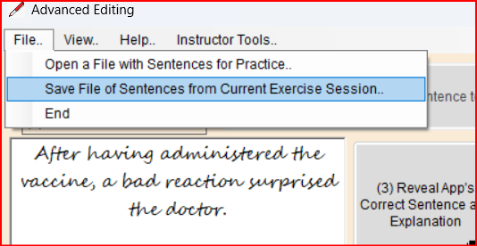
You will be prompted for a file name. I suggest using your first name or initial and last name as part of the file name. Take a note of where the file will be saved (maybe you want it in your “Documents” folder, or on a flash drive). It’s possible that the App will think you want this new file of yours in the same folder as the App itself is in. Please be careful: don’t save the file with a file name that is identical to a file in the App folder. It might be best to avoid that folder altogether when saving. When you know where you want the file to be saved, click “Save” and the file should save automatically as a Word type file.
Restricting Exercise Sentences to Certain Categories.
You can force the App to bring up sentences from the specific “Error Category” you choose. Error categories include “DANGLING,” “PRONOUN”, “WORD LEVEL”, “SENTENCE” (short for “Sentence Structure”) and others. For instance, you can focus on the Error Category “SENTENCE” to work on run-ons, fused sentences, and fragments.
On the upper right side of the screen there is a list of Error Categories in what is called a check box. You could scroll down to “SENTENCE” and select it, as illustrated in the portion circled in red on the image below:
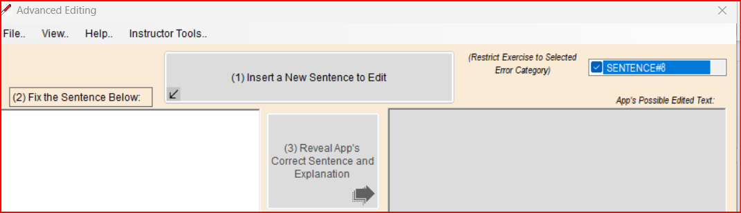
This means that the App will only pick sentences that have been associated with the error category “SENTENCE” when it looks for random sentences. So as you proceed through the Steps (1) – (3), the App will generate a random number, look to see if the sentence with that random number contains the Error Category “SENTENCE,” and then present it for you to edit. The App also checks to see if you have already seen that sentence in the current session; if you have seen it, it will try again with a new random number. In this way, the App will give you the maximum number of sentences with that Error Category in its list (currently 8 sentences for Error Category “SENTENCE”), until all have been completed. It will then start again, with a different random order. (Other Error Categories have more than 8 sentences, others have less. Your professor and I will work on designing more than the 70-odd total sentences that are in the App at the time of this writing).
Help When Editing.
After you click “(1) Insert a New Sentence to Edit,” the App finds a sentence with an error and places it into the white typing box. If you right-click on the box before you start typing, a “context menu” appears in that box:
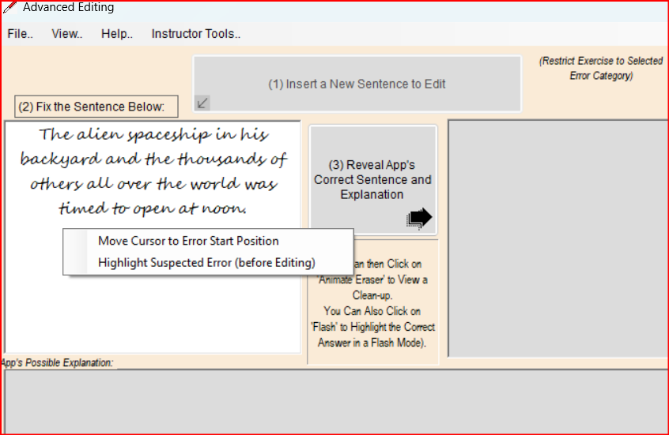
If you select “Move Cursor to Error Start Position,” the App will move the cursor to where it “remembers” the wrong word or phrase starts, in other words, where the expected error is. This could help you if you cannot sense just what is wrong with the sentence as presented to you. In this case, the cursor would move to the position of the word was, so you would know where to start editing.
If you select “Highlight Suspected Error (before Editing),” the app finds the expected error and highlights it:
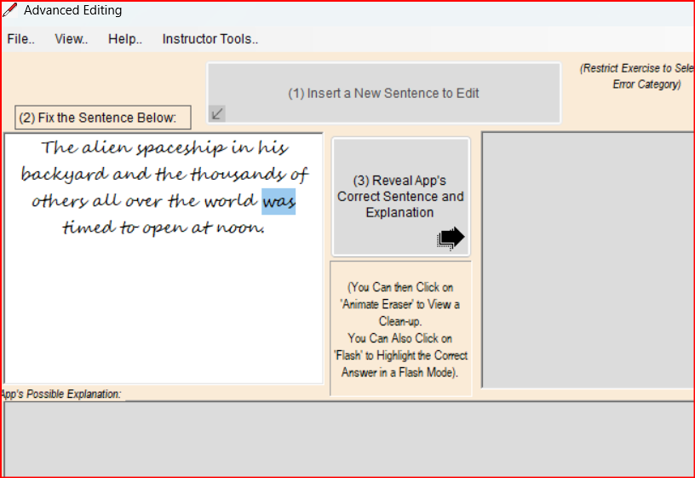
So again, you have a strong hint as to the nature of the error, and what you need to revise in the sentence.

